AvAr Activity Report

Date of Action: 26 May 2014
Investigator: Ron Miller.
Other Party Members: None.
Site Investigated: West White Pine Mtn C-46.
Mileage- 102 miles round trip from Ft. Collins.

Purpose of trip: Hike to the site and assess impacts from the High Park Fire of 2012 and the subsequent flooding rains of Sept 2013.

Report : (Changes since 2009 report show italicized)

Site formerly consisted of a clearing fringed with aspen shoots in the thin dog-hair pine on the side of the mountain. Now the site has been burned intensely. Pine trees are now just charred black sticks and the organic forest floor layer has been burned away leaving mineral soil.
During 2013 the NFS spread hay over much of the mountain using helicopter delivery.

Most recognizable part on the site remains a single gear leg assembly with scissors. It is now scorched where it was once painted. Black soot/charcoal layer over the site has been rained on and flowed as mud. Many components are hard to see in this state.

Pictures will be included in this report.

Other parts from previous report- (did not re-inventory)
- Multiple drum lid clamps of varying sizes. Paint has been burned and the cans are corroding.
- Wads of control cable near the gear leg
- Section of ignition wire harness conduit with wires cleanly cut
- Pair of phenolic control cable pulleys.
- 4 pulley stack consisting of pair of large pulleys (6"?) against pair smaller pulleys (4"?) all of aluminum. Control cable ends are swaged to the pulleys. Picture included.
- Shallow compartmented metal drawer about 12"wide x 8"deep by 2.5" high white painted. Now the paint is burned off and surfaces are rusty.
- Melted glass vacuum tube.
- Vacuum tube socket (not in proximity to above)
- Hunk of metal with part number 20-020-1065-4L
- Paper filters : Paper, if any, is now charred though the endcaps remain in profusion.

Access
Previous trip reported bermed off (NFS blocked) recovery road from the Flowers Road to the crash site winding across the face of the hill then steeply upwards. Steepness (30 degrees in some places) plus narrowness plus facts of turning path on this steep a grade lend doubt to the idea that trucks carried material from the crash site downwards. A tramline may have been rigged. Evidence of line anchors to trees has been burned away. Some short sections of steel cable found slightly below the site on the "road" tend to suggest winching operations of some kind. Numerous 5 gallon round gas/kerosene cans on the hill suggest some portable gas powered equipment used as either part of the recovery or later (logging).

For 2014 the Flowers Road is Closed by the NFS due to treefall hazard and significant erosion. Only foot travel is authorized from the closure to where the trail leaves the Flowers Road. This made the trip 8 miles round trip with a gain and loss of 1500’ elevation.

Because the organic material has been burned off the forest floor, following the access road from the Flowers Road to the site was problematic. It all looks alike now! Careful study of tree spacing was the only visual clue to the location of the trail. Prior GPS waypoints were utilized to confirm on course. In several cases I strayed off route without indication other than GPS.

I had anticipated that the burn-off of material would expose more bits of wreckage that may have fallen off the truck/sled during removal. Instead, I found that several long stretches of the trail and ground to either side were covered with air-dropped hay making route-finding difficult and precluding sighting of additional debris.

The GPS waypoint “sawpile” has burned away and cannot be discerned. A drum and a gascan at that spot remain. ‘Sawpile’ was a mound of tree bark slabs from a portable sawmill setup from sometime in the past.

Road Debris Trail

Non-descript aluminum (NDA) was found on the roadbed above the sawpile site. As shown below: (from2009 report) 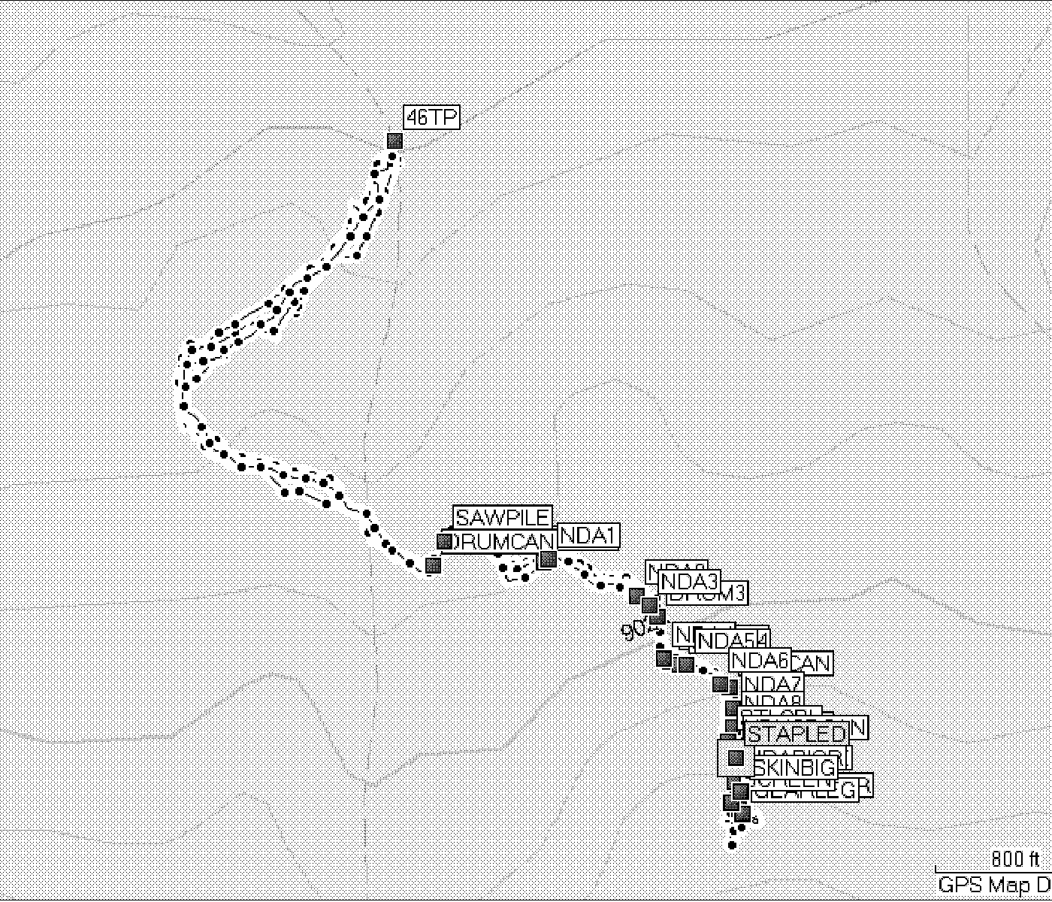

Fig 1 Large view NDA field

Figure 2 Coordinates (subset from 2009 report)

Waypoint name | UTM (WGS84 datum) | Alt. | Description
46TP | 458951 4497149 | 8000 (est) | Car parking at Flowers Trail
SAWPILE | 459025 4496541 | 8820 ft | Slab pile from movable sawmill
GEARLEG | 459476 4496124 | 9431 ft | Reference point on site

Crash-caused clearing

I previously recorded the outline of the clearing the wreckage lies in using GPS. Small aspen which likely have grown up since the crash were disregarded. The clearing measures 151' in length on an axis of 346 degrees magnetic. Waypoint GEARLEG is the reference point since it's the biggest recognizable part in the area.

There is still a crash-caused clearing on the site but without vegetation its presence is much less obvious.

Pictures: (sizes vary according to need for detail)

When vehicle accessible – I parked here.

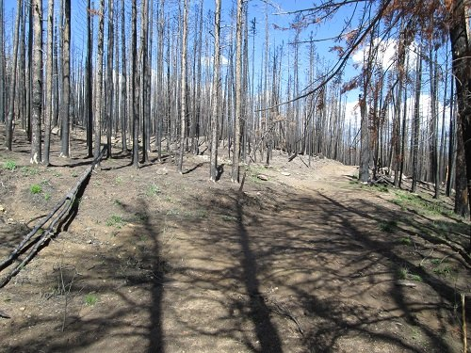
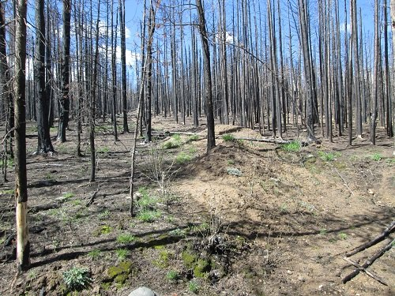

Trail is indistinct under air-dropped hay
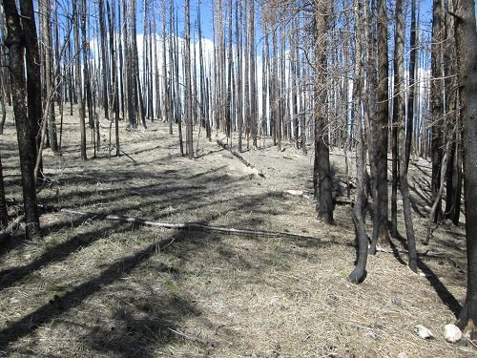

Running water obscures that this was the trail
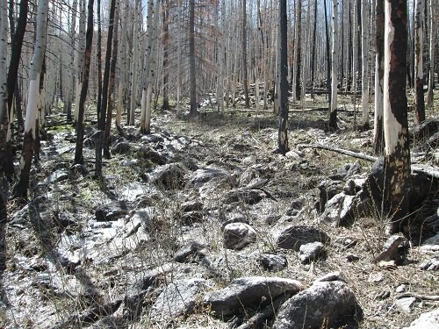

Former location of ‘sawpile’ (yellow paint on gas can at center)
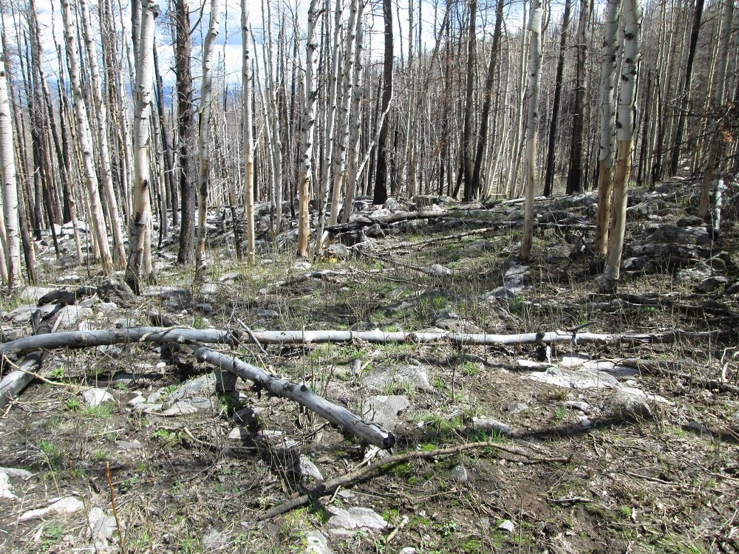

Three burned drums on hill
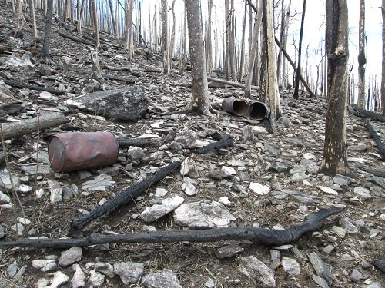

View out from hillside- trees all burned
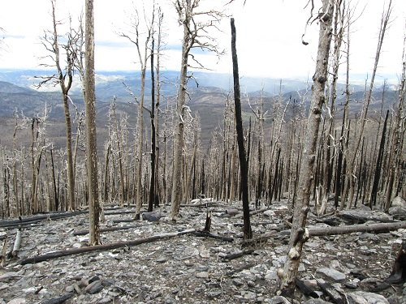

Exhaust manifold section
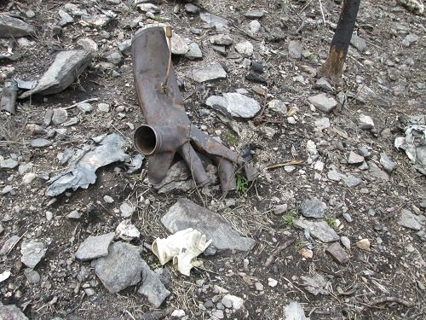

Gear leg & site general (uphill from exhaust manifold). Wheel is visible at top of snow drift.
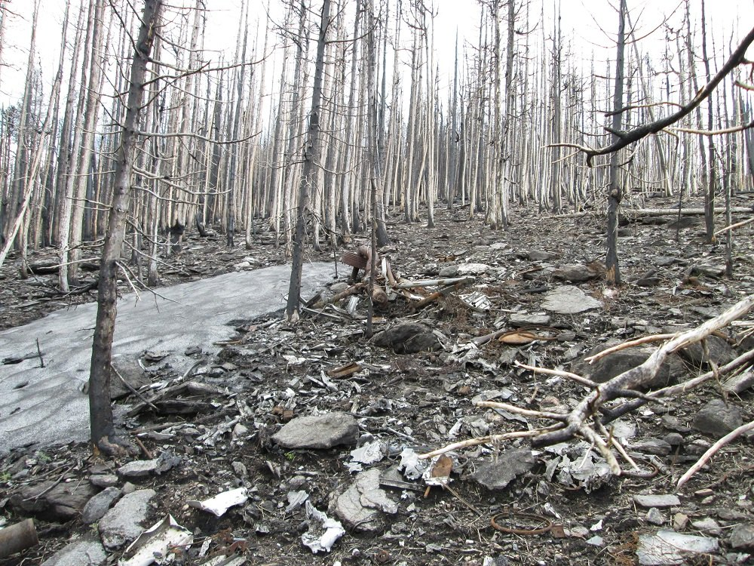

Typical site litter – melted aluminum, tubing, pipe fittings,brackets, tiny washers, etc
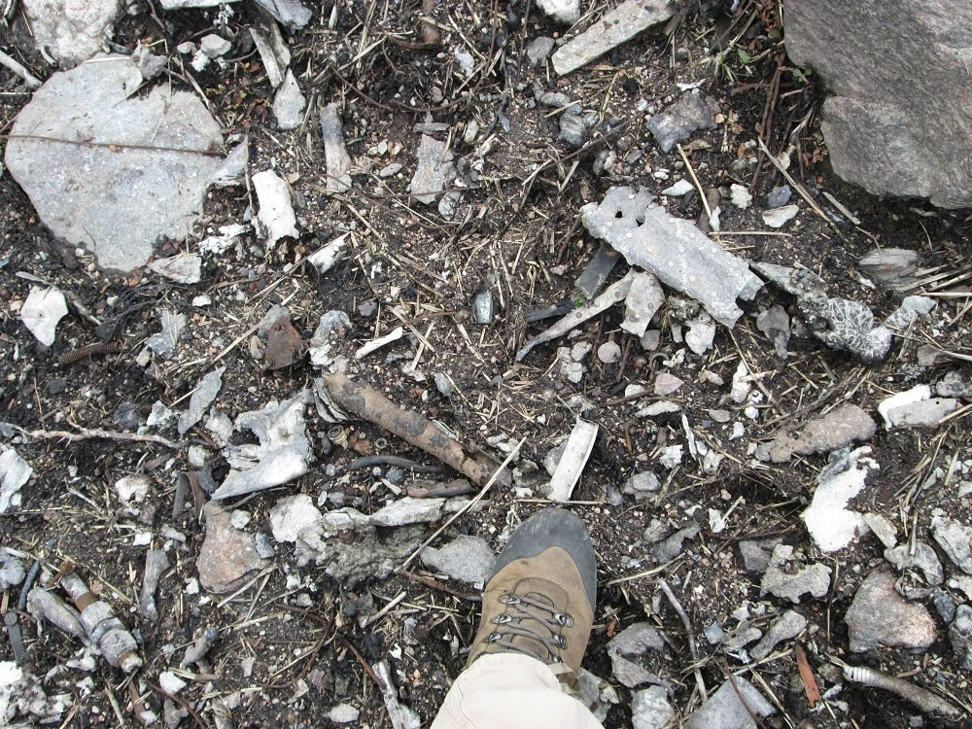

Filter – with partial element, internal spring next to electrical fuse.
Likely one of the drums was packed with these filters as there are large numbers of the end caps on site while the filter paper has decayed.
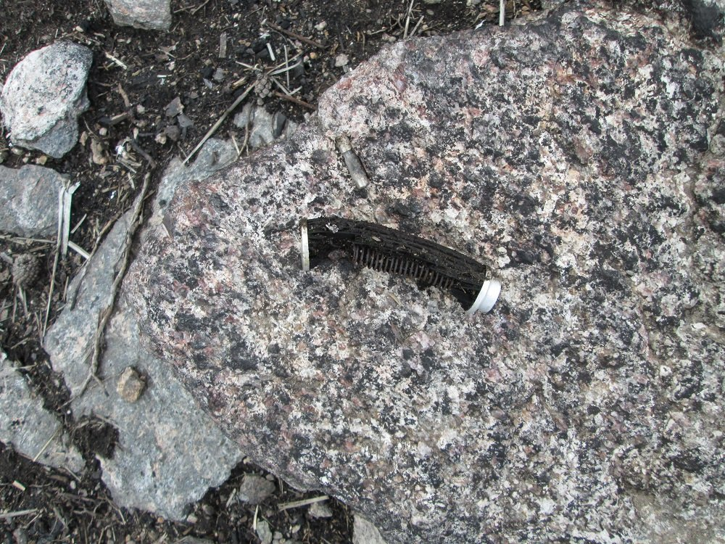

Wheel and Strut
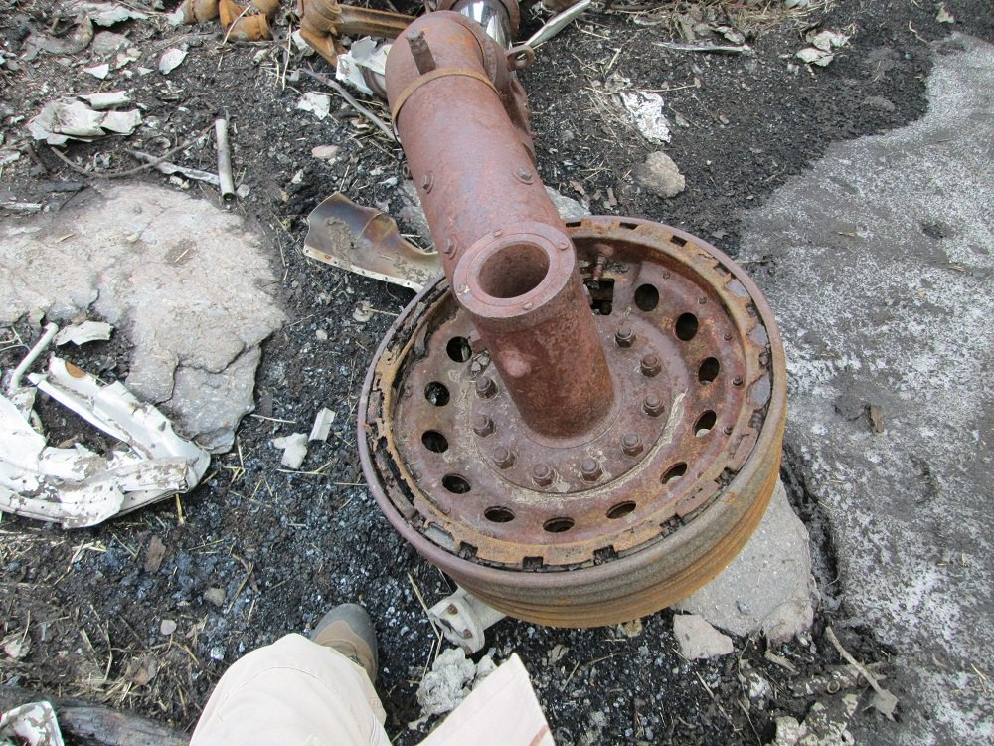

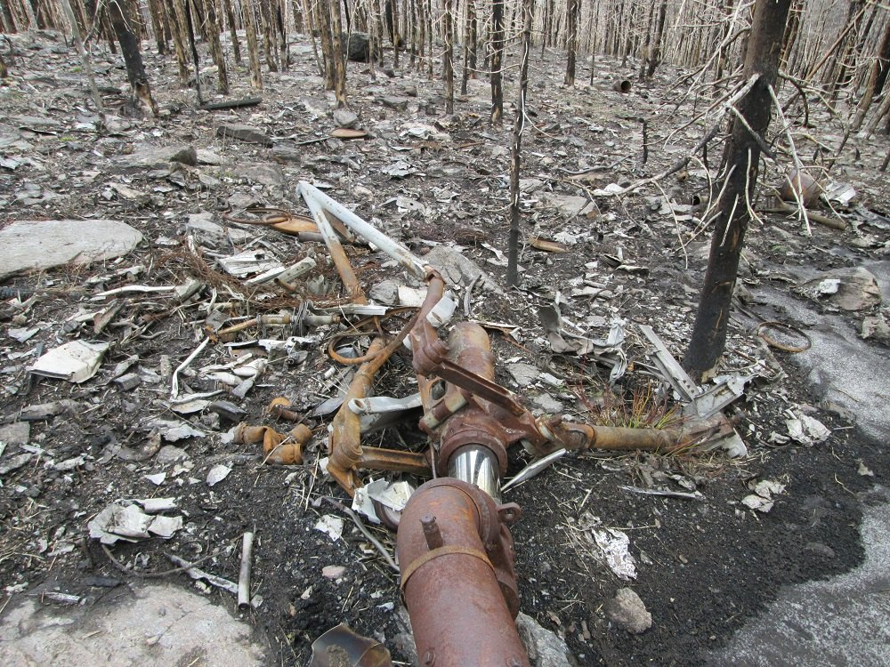
Aluminum pulleys
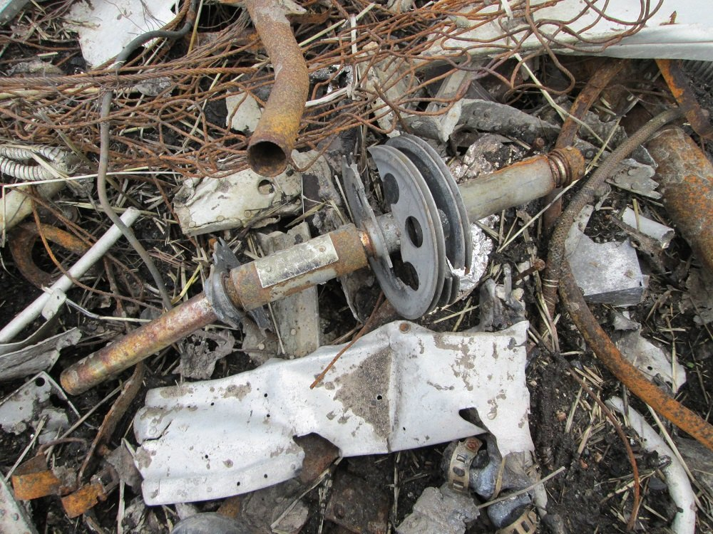
Uphill view of site
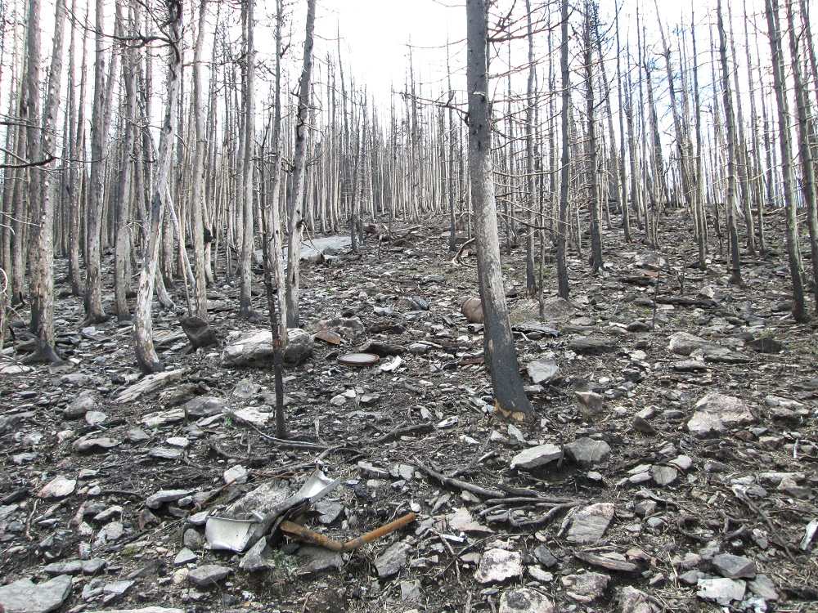
View approximately matches one on my website from before the burn

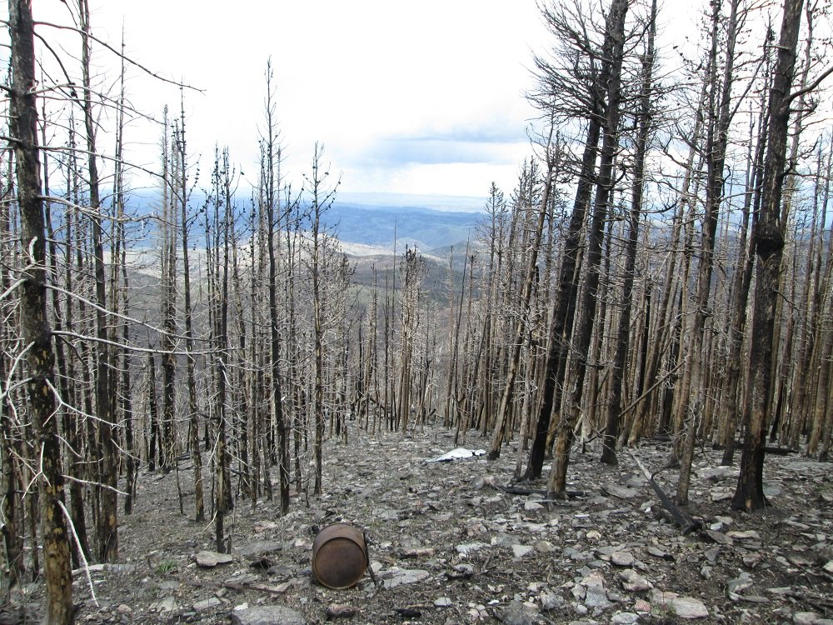

Fieldcraft notes:

- Terrain – Terrain is sloping pine woods with slope gradually steepening with height. Followed a logging/recovery road which became very steep as it ascended the hill directly near the crash site. Pines are realatively small diameter and closely spaced with little undergrowth. Pines are now charred sticks and pine needles under them have been burned away. Visibility thru the woods is quite lengthy now.Logging road hard to follow now.

- Weather for this trip was 60's with little breeze. Given the lack of branches, air movement caused no sound at all. Also because of the fire there is little shade to be found. Not every tree burned but the overall effect is that there is no shade. A thunderstorm brewed up while I was in the woods but it did not pass close enough to me to cause any change of plan.

- Animals- 3 Elk were startled out of the woods about 1 mile from the car. Deer tracks, elk tracks and bobcat/lion tracks were found. Woodpeckers are working on the trees.

4. Water. Several gullies were running with a great deal of water including one which destroyed the Flowers Road roadbed leaving only one wheel-width intact.

