

The Jimmy Camp B-24 Site
In
Multi Spectral Analysis
By Larry Liebrecht Jr.

Satellite Imagery provided by the GeoEye Foundation with Digital Image Processing Software by Envi - Exelis
Lawrence Liebrecht Jr. 12-31-2012
Colorado Aviation Historical Society – Aviation Archaeology Group

Area of Research: Aviation Archaeology; a Sub-Discipline of Historical Archaeology dedicated to the Discovery, Study and Preservation of Sites & Artifacts related to aviation and aerospace history.

Jimmy Camp Project
Target Coordinates: REMOVED FOR SECURITY
Land is now owned by the City of Colorado Springs and was slated for watershed, reservoir and light recreation development as of 2007. Cross country access to the site was provided by special permission through the surrounding ranch.

The Jimmy Camp Colorado B-24 crash site is an example of a state-side WW-II training accident. The accident took place within viewing distance of Peterson Field, in Colorado Springs, Colorado. On September 14th, 1944, at 16:16 MWT (Mountain War Time) US Army Air Corp B-24D Ser. No. 42-73359 crashed approximately 5 miles North East of Peterson Army Air Field, Colorado Springs, Colorado while on a routine training flight. As the aircraft was rejoining a formation of other B-24 bombers, the subject aircraft lost controlled flight after getting too close to the aircraft ahead; the prop wash generated by the leading aircraft induced the subject into a “flat spin”, which the pilots were not able to recover from. There were no survivors.

Site Characteristics: The “Jimmy Camp” site is on the eastern outskirts of Colorado Springs & was historically utilized by indigenous populations, trappers and wagon trains for its ample sources of water, food and shelter. The site geography is characterized by predominantly sandy rolling prairie intersected by ravines and creek beds; running generally North to South. Bluffs are to the West, North and East. Flora is predominantly natural prairie grasses; cactus and low pine trees that provide a flourishing habitat for the deer, antelope and coyotes that inhabit the area..

The major point of impact for the aircraft consolidated the wreckage of the front sections (cockpit, wings and engines) in one area on the east facing hillside approximately 20’ below the western bluff. Photos taken at the time of the accident by the Army recovery team and heat damaged aluminum debris found at the site confirm our findings and the event of fire at this site. A second debris field containing sparsely scattered, mainly small and non-combustible, components from the rear of the aircraft lies approximately 75 yards to the east. This area is not addressed further in this report due to the sparse scattering of identifiable components and non-combustible nature of the site.

In an attempt to develop a better means of locating and documenting this, and other crash sites, a program was developed to test a theory on the feasibility of using High resolution multy-spectral satellite imagery to develop a fingerprint analysis system, and eventually an algorithm for large area search for aviation crash sites based on residue of petrol and chemical remains. The petrochemical residue is the byproduct of the fire that consumed the aircraft at the time of the crash, and non consumed oil and fuel as well. The fire was extensively feed by thousands of gallons of aviation fuel, oil and self-sealing fuel tank materials. After 65 years, Vegetation stress is visible from ground viewing in late May in the area where the wings and engines came to rest and burned. This tool would also be usable by Search & Rescue personnel, the Department of Defense and FTSB. Panchromatic imagery alone is not reliable due to human cultural and livestock activity.

An Imagery Grant was obtained from the Geo Eye Foundation to cover the expense of imagery from their archives; and a software grant was obtained from ITT Visual Information Solutions in the form of utilizing their ENVI software for analysis of the imagery. Findings were presented at the April 2011 Aviation Archaeology Conference at Nellis Air Force Base, Nevada; Wings over the Rockies Air & Space Museum, Denver CO in September 2011; GIS Colorado in May of 2012, and GIS in the Rockies 9-21-2012, as well as other presentations throughout the Front Range metropolitan area.

Data: 3 Multy-Spectral Satellite Images of varying High Resolution provided by GeoEye over a 4 year period from 26 May 2003, 7 September 2006, and 3 April 2009. Bands analyzed were NIR, Red, Blue, Green and Panchromatic. Bands were analyzed utilizing various stretching techniques as well. The April 2009 imagery giving the most information due to appearance of higher resolution, vehicle activity, and yet also somewhat degraded by several years of surveying of up to 20 people per trip. Even being less degraded by human activity, the pre survey imagery from 2006 and 2003 could not clearly identify a specific spectral signature for the crash sit as compared to other barren stretches of ground.

The most recent coverage obtained, 3 April 2009 appeared to give the best results per quality resolution (possibly due to satellite system upgrades). Stretching in all bands improved the contrast of image details in most cases, and brought out small individual details. Repeated analytical results indicated that if the location of the site were not known, it would not be possible to positively identify and distinguish the crash site from animal or natural physical erosion activity.

Conclusions: After intensive study and analysis of the satellite imagery a clearly defined spectral-fingerprint could not be isolated. Stressed vegetation and areas barren of vegetation none to be in the crash site burn area show no differently then stressed area due to animal activity. The area identified in figure is probably barren of vegetation due to the initial killing of the vegetation and its inability to grow back after such a catastrophic disturbance of the local flora and soil in such a fragile environment as seen in figures 1,3,4,6 and 7.

Two primary reasons for lack of identifying this spectral fingerprint appears due to Be: 1) low resolution of the highest resolution commercially available satellite imagery of the target area vs. the small, but proven contaminated, burn area; 2) approximately 65 yrs of wind blown soil/silt covering some areas of the crash site. Silt 6 to 9 inches deep was found above a 4” band of soil containing petroleum residue. This contaminated soil still stung the eyes and nose when uncovered while digging a small test pit in the area where the wing and engines came to rest. Hopefully future system developments will improve capabilities.

Given the subject crash site lies several feet below the rim of a hillside to the east of a higher, gently rolling prairie, a better site with less silting should be utilized to test this theory until more sensitive satellite systems become available. Unfortunately, at the time of this study the only better site had snow covered imagery.

Current efforts are under way to further test this theory with the Colorado Civil Air Patrol utilizing its airborne multy-spectral sensor assets, reportedly with higher resolution capabilities as compared to commercially available high resolution satellite platforms.

A positive collateral development was clearly identified between the images analyzed. In comparing the pre ground survey imagery of September 2006 with that of April 2009. A clearly delineated area of vegetation stress was obvious due to vehicular activity in the parking area and along the ranch trails used to access the site. (See Figures 11, 12, and 13) This underscores the importance of limiting vehicular activity in study areas; and also how easily our environment in the high desert prairies of the west can be damaged. A good topic for a future study.

I would like to thank the folks at GeoEye and ENVI for their support in this endever. As better systems come on line to the public, the results of studies like these should improve, and I know they will be at the forefront of such activities.

Please Note: All artifacts are the property of the City of Colorado Springs.

All publication rights for this report are reserved by Larry Liebrecht Jr. Educational reuse of this report without profit is permissible.

Jimmy Camp – Colorado Springs Orientation

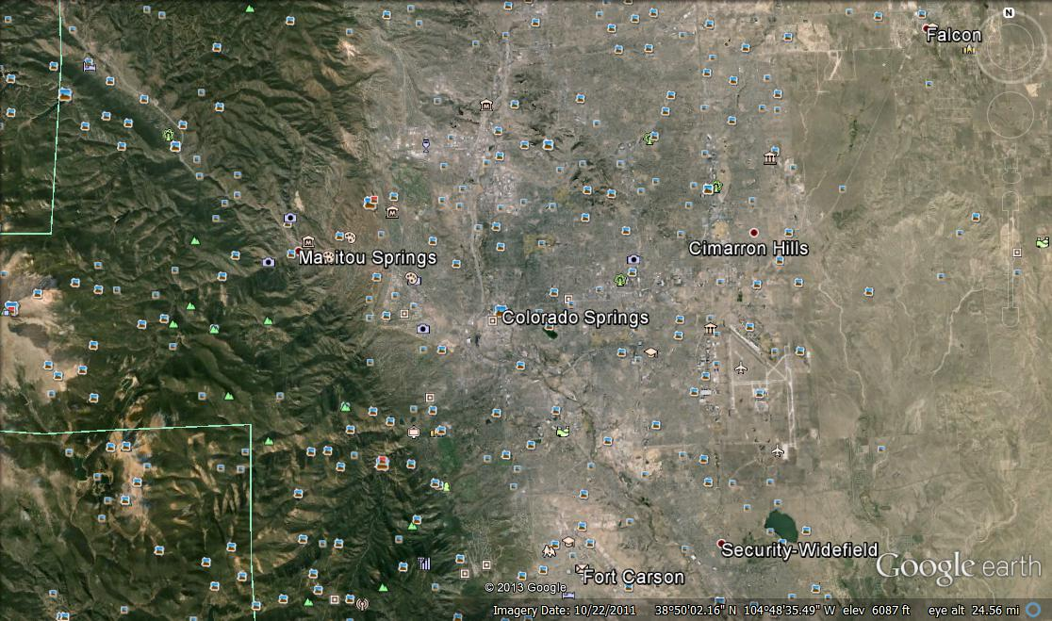

ORIENTATION IMAGE EDITED FOR SITE SECURITY

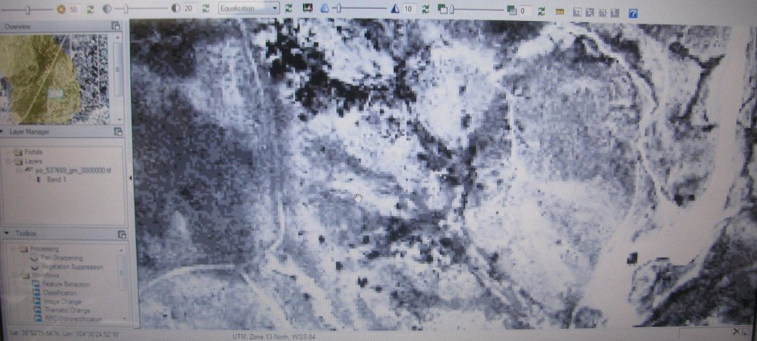
9-7-2006 GeoEye Blue Band Image – Equalization showing location & coverage of site area. Dark patches are healthy/healthier vegetation.

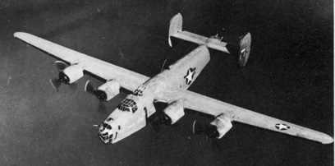
Early B-24 bomber similar to the subject aircraft (US Archives)

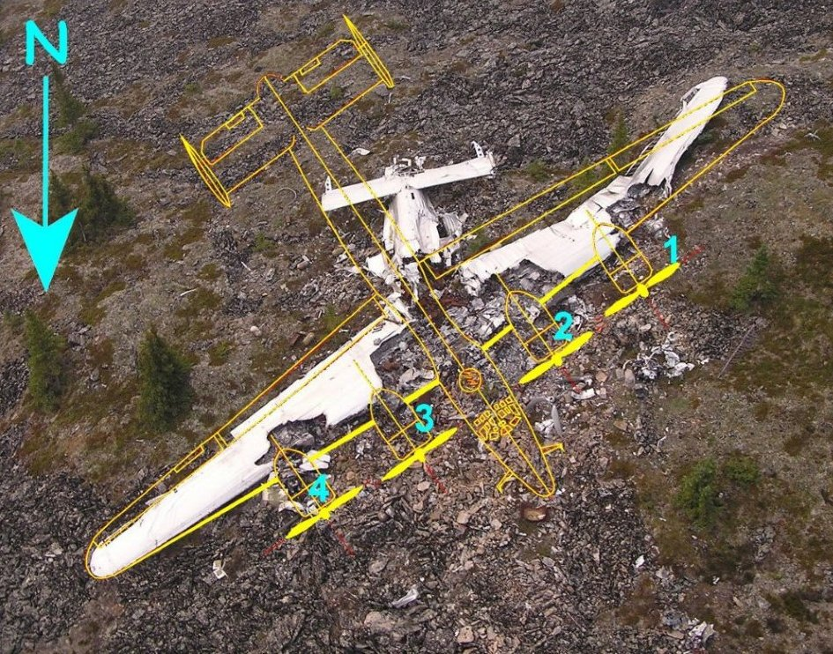

Typical burn pattern for a B-24 victim of a Flat Spin (US Forest Service). Note heaviest fire damage towards center of aircraft and inboard fuel tanks between engines 2 and 3. Lesser burn damage around outboard engines 1 and 4.
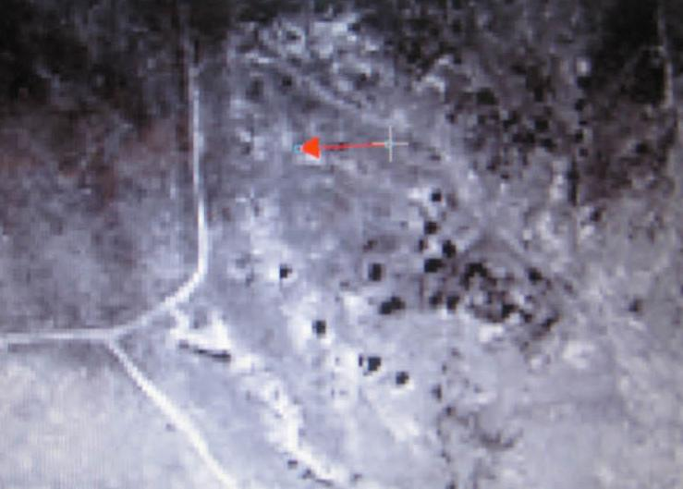
Orientation image: Arrow points to approximate location of crash site. GeoEye 4-3-2009 Blue Band Linear stretched Imagery processed with ENVI software. Fig.1

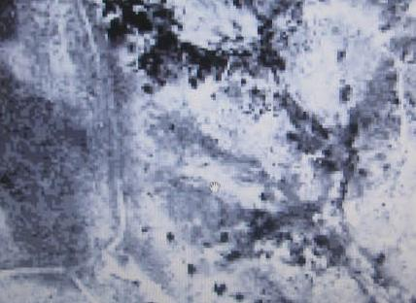
9-7-06 GeoEye Blue Band Imagery stretched with Equalization close-up. Image pixilation appears inadequate & data inconclusive for analysis of our problem. Fig.2

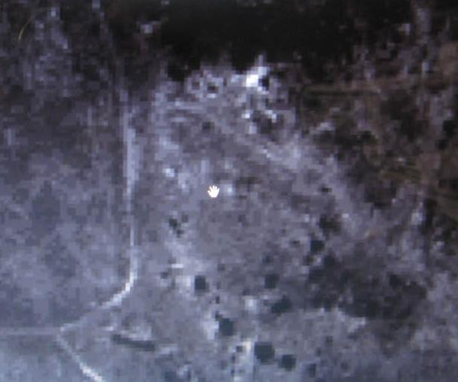
4-3-09 GeoEye Image Blue Band Logarithmic stretched. Trails stands out and the light pixel near parking area (at 10o’clock to hand marker) matches sand cover at the bend in the trail to South. This is really close to sight. Fig.3 above
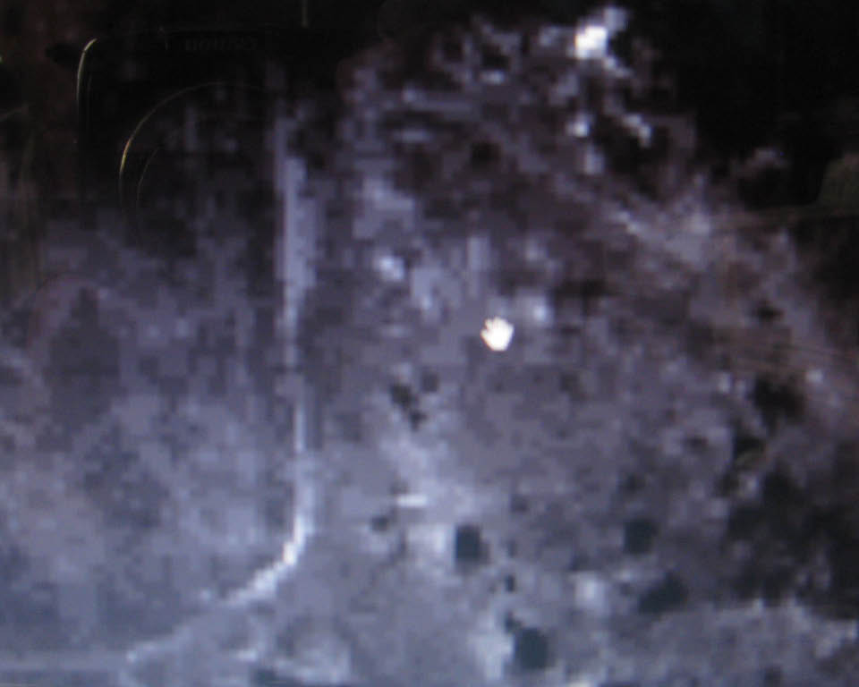
4-3-09 GeoEye Image Blue Band Logarithmic stretched Close-Up. Fig.4

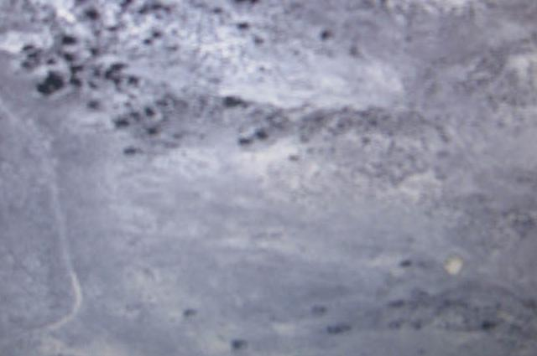

9-7-06 GeoEye Image Blue band with Optimal Linear stretched. Not much detail.
Fig.5

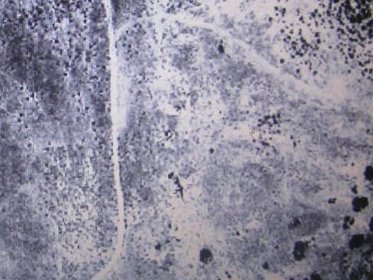
4-3-09 GeoEye Pan Image - Linear Stretched. Good detail indicating the location of the crash site in study (light blotch to the east of parking area). This blotch is also visible on older imagery but could be due to the natural break in the topography due to erosion.
Fig.6

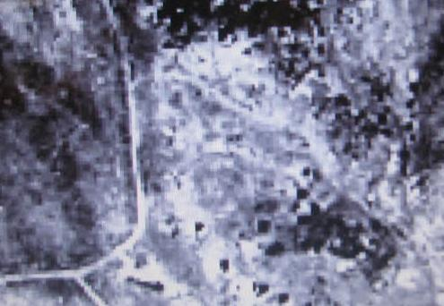
4-3-09 GeoEye NIR Image Equalization stretched. Note the light shaded zigzag pixels just East of parking area between two dark patches. This is at the angel in which the forward section of the aircraft came to rest. Hope to research further with airborne sensors of the Civil Air Patrol, etc. Fig.7

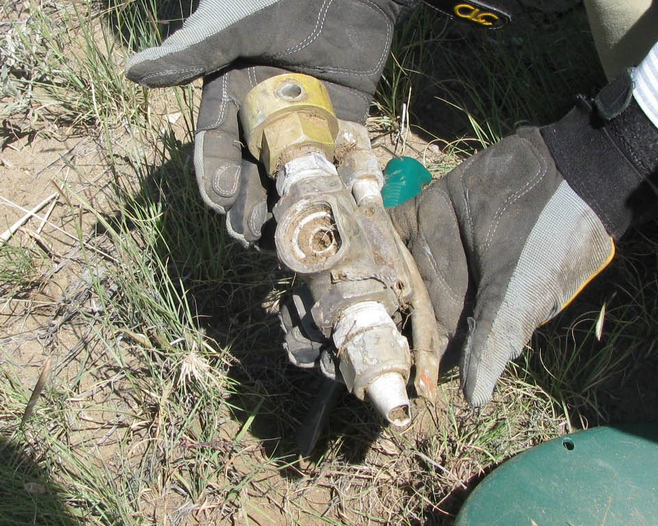
Fuel Cross-Over valve, found in area containing forward section of B-24. Valve is located in the bomb bay area to allow for fuel exchange between wing tanks for balance. Photo by Larry Liebrecht Fig.8
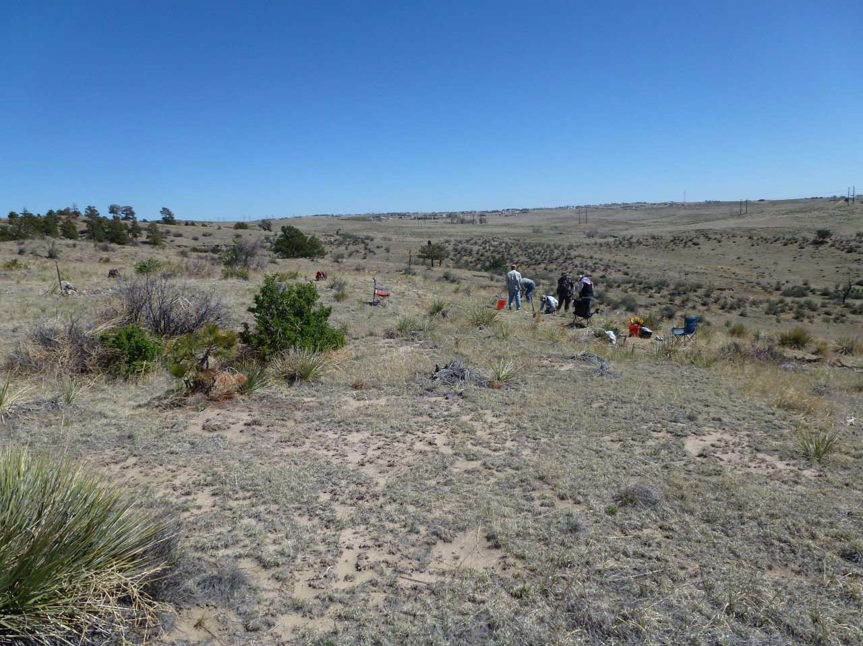
View Looking North over forward section excavation. Fig.9
Photo by Larry Liebrecht Fig.10 below
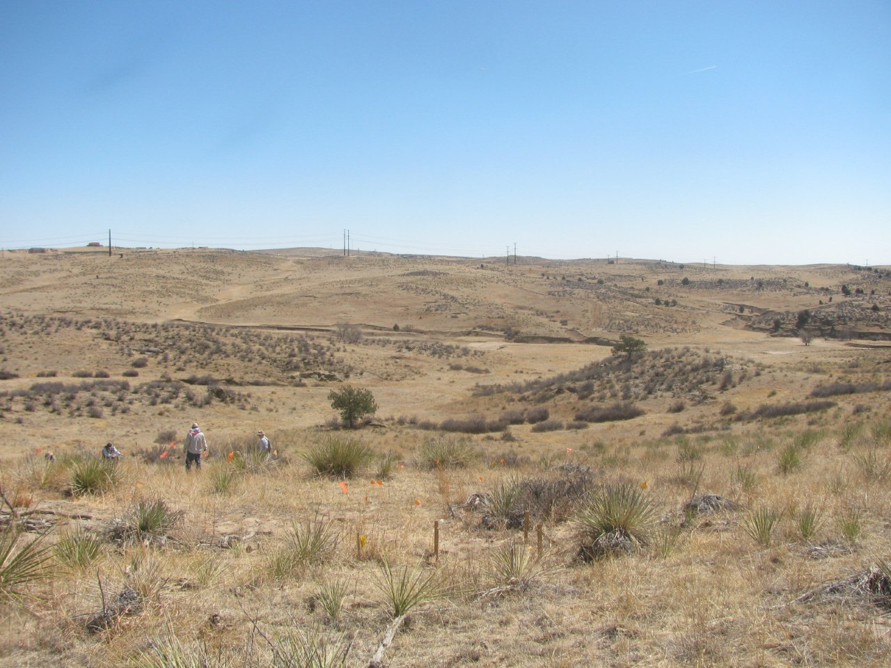View to East over looking crash site. Note sandy soil and sparse vegetation. Note the two tall trees in the photo for orientation with satellite imagery. Photo by Larry Liebrecht

Vegetation Stress due to vehicles. Fig.11 below
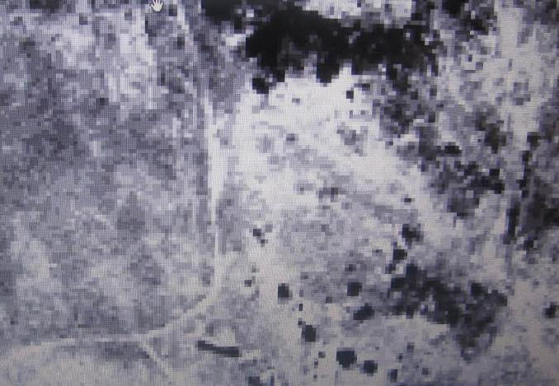
4-3-2009 Blue Band GeoEye Image stretched via Equalization with ENVI software – Note parking area along east side of trail heading north (bright return widening trail).
Fig.12 below
9-7-2006 Blue Band GeoEye Image stretched with Equalization processed with ENVI software – Note the absence of vegetation stress along east side of trail heading north. Area was not utilized for parking at date of image. Survey began in 2007.

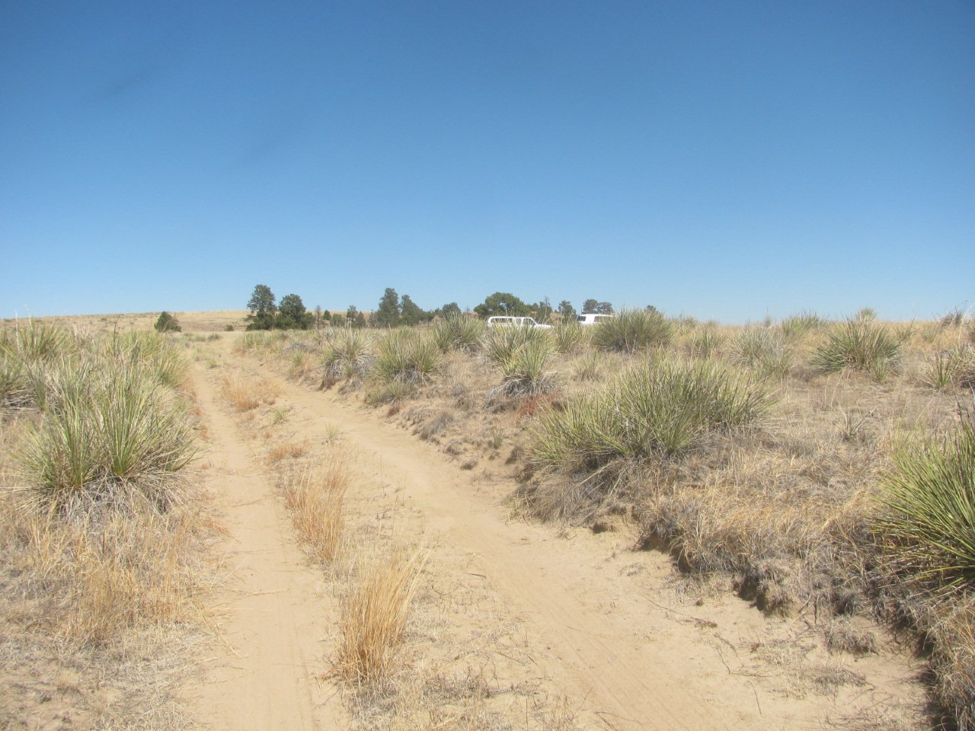
Sandy Trail looking north with Parking Area to right (East). Fig.13

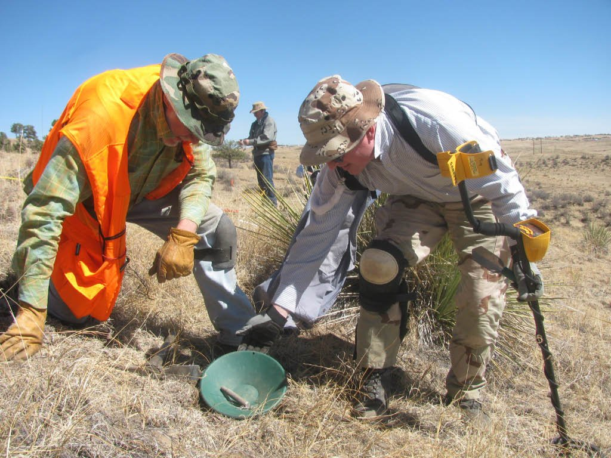
50 Cal. Shell Casing artifact found near the forward section of fuselage area. This B-24 saw combat over Europe before being relegated to pilot training. Reportedly, this aircraft never fired 50 Cal rounds stateside. Photos by Larry Liebrecht Fig.14

